TABLE OF CONTENTS

1.0 INTRODUCTION 5
1.1 Background 5
1.2 Project Scope 5
1.3 Scope of Document 5
1.4 Definitions 7
1.5 Acronyms 7
2.0 REFERENCE DOCUMENTS 8
3.0 EXECUTIVE SUMMARY 9
3.1 Gathering Production Network 9
3.1.1 High Level Line Sizing- Configuration Screening 10
3.1.2 Production Network – Deliverability 11
3.1.3 Production Network – Arrival Temperature 13
3.1.3.1 Continuous MeOH Inhibition 13
3.1.3.2 Continuous Wax / PPD Inhibition 13
3.1.4 Production Network – Arrival Flowrates 13
3.1.5 Production Network – Velocities and EVR 14
3.2 Gas Lift System 14
3.3 Water Injection System 15
4.0 BASIC DATA AND METHODOLOGY 16
5.0 PRODUCTION GATHERING NETWORK 17
5.1 High Level Production Line Sizing – Configuration Screening 18
5.2 Steady State Analysis Basis 18
5.3 Deliverability Production Profiles 19
5.4 Deliverability Results 21
5.4.1 Overall Deliverability 21
5.4.2 Well by well Deliverability 23
5.4.3 Gas Lift Sensitivity 24
5.5 Subsea - Pressures and Temperatures 25
5.6 Flowline – Pressure and Temperature Profiles 27
5.6.1 Pressure Profiles 27
5.6.2 Temperature Profiles 28
5.7 EVR, Fluid Velocities and Pressure Drops 29
5.8 Arrival Conditions 30
5.8.1 Arrival Temperatures 30
5.8.1.1 Continuous Hydrate Inhibition 31
5.8.1.2 Continuous Wax / PPD Inhibition 32
5.8.1.3 Topsides Choking Impact – Pressure and Temperature 32
5.8.1.4 Topsides Choking on Flow Stability 33
5.8.2 Arrival Actual Flowrates and Flow Stability 34
6.0 RESULTS – GAS LIFT SYSTEM 35
6.1 Gas Lift Requirements 35
6.2 Gas Lift Steady State Results 35
7.0 RESULTS – WATER INJECTION SYSTEM 38
7.1 Water Injection Profiles 38
7.2 Water Injection Steady State Results 38
8.0 ATTACHMENTS 40
8.1 Subsea Upstream and Downstream Chokes 40
8.2 Initial Line Sizing - Configuration Screening Presentation 40

INTRODUCTION
Background
EBAN development will be developed into 2 phases as follows:
Phase-1: 1-off oil production well connected to Flexible flowline, to riser base gas lift subsea structure through two Flexible risers to FPSO.
Phase-2: Add the 2nd oil production well, water injection well and Flexible service line and all related flexible flowlines and flexible risers.
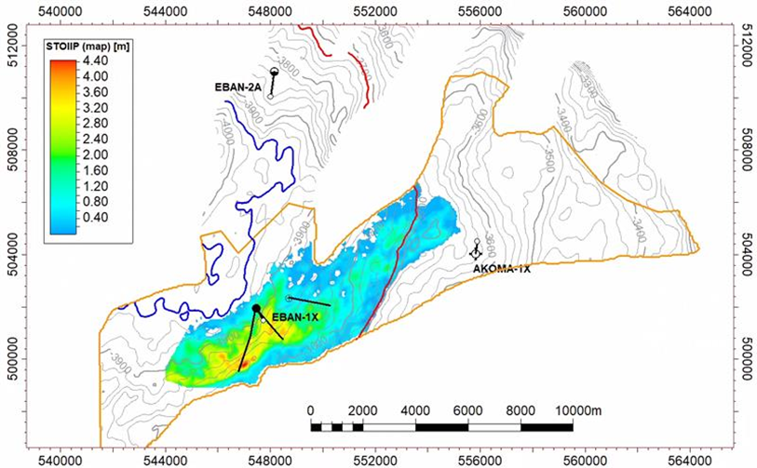
OP-1

OP-2

WI-1

v

Development Wells location
Project Scope
The project scope of work is divided into two main work packages:
- WP1: Subsea, Flow Assurance and Offshore Flexible Pipelines, FEED Phase.
- WP2: Topside modifications and new tie-ins (including follow-up to FPSO contractor Feasibility/FEED)
Scope of Document
The steady state flow assurance analysis for EBAN Field development with reference to the production and water injection systems showed in Figure 1-1 and Figure 1-2 respectively, has been conducted to:

- Verify and optimize production configuration subsea networks in terms of hydraulic and thermal performance
- Define the main operating parameters (such as pressure, temperature, actual volumetric flowrates, EVRs, etc.) to be used for the design of the facilities
- Assess any potential flow assurance issue (such as hydrate formation, WAT threshold, slug regime etc.) and propose relevant mitigations.

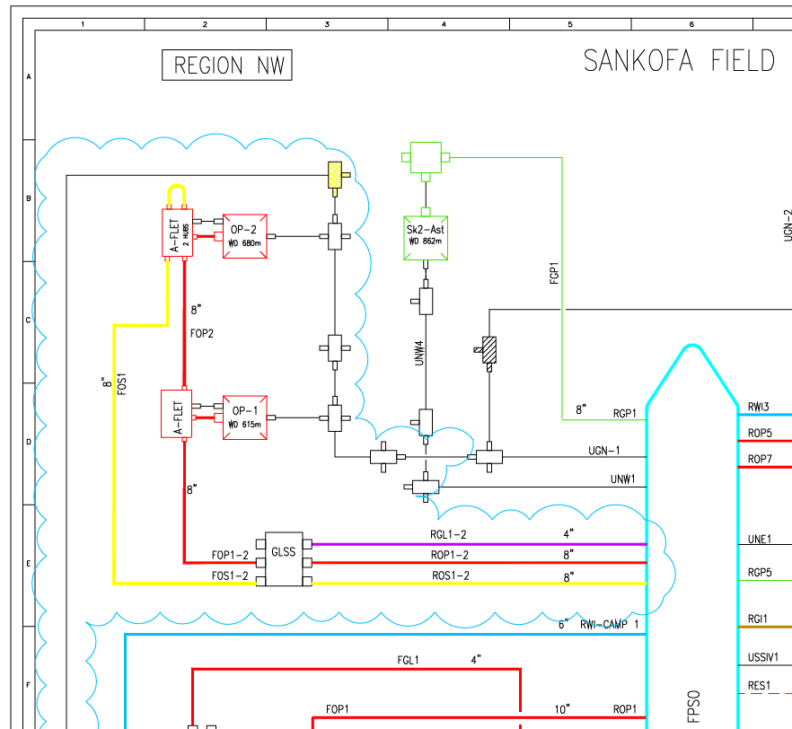
Figure 1-1: Field Layout schematic – Production and Gas Lift

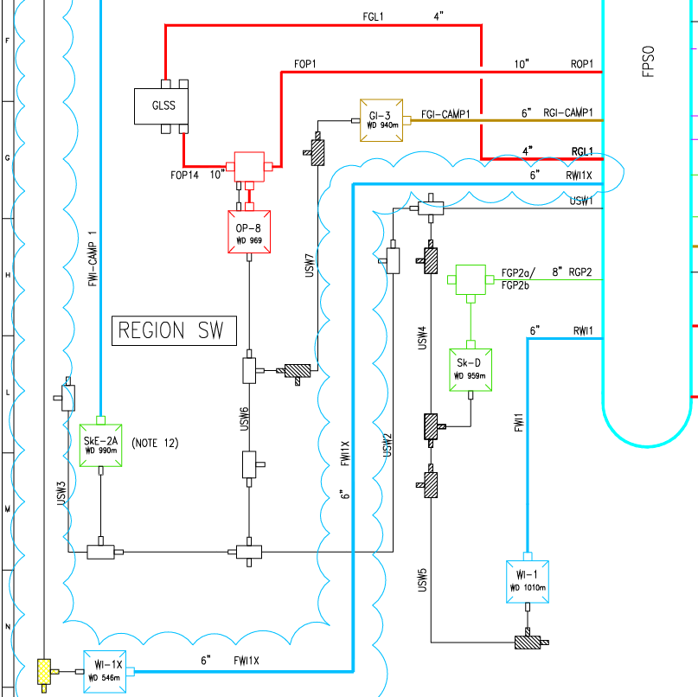
Figure 1-2: Field Layout schematic – Water Injection
Acronyms
API | American Petroleum Institute
bbl/d | Barrels Per Day
CDT | Cool Down Time
CS | Carbon Steel
DC | Drilling Center
EVR | Erosional Velocity Ratio
FEED | Front-End Engineering Design
FPSO | Floating Production Storage and Offloading
GLSS | Gas Lift Subsea Structure
GOR | Gas Oil Ratio
GL | Gas Lift
ID | Inside Diameter
LLL | Low Liquid Level
NLL | Normal Liquid Level
OD | Outside Diameter
OHTC | Overall Heat Transfer Coefficient
PPD | Pour point depressant
PLET | Pipeline End Terminal
STB/d | Standard Barrels Per Day
Scf | Standard cubic feet
THI | Thermodynamic hydrate inhibitor
PCV | Pressure Control Valve
PVT | Pressure; Volume; Temperature
RBGL | Riser based gas lift
SoW | Scope of Work
U-Value | Thermal Transmittance
WAT | Wax Appearance Temperature
WC | Water Cut
WHFP | Well Head Flowing Pressure
WI | Water Injection

EXECUTIVE SUMMARY
The present document shows results of flow assurance analysis carried out for the EBAN field development.
The subsea system relevant to Flow Assurance analysis consists of:
- Gathering production systems
- Gas-Lift Distribution system
- Water injection network
The deliverability of the wells has been verified for each expected production year to confirm the forecasted reserve volumes to be delivered, or to identify any potential criticality or production delays. Moreover, the design scenarios both for production and injection networks, consider representative production years along the whole asset life and used as a reference for transient analysis.
Gathering Production Network
Figure 3-1 and Figure 3-2 show schematics for the Production system in Phase 1 and 2 respectively. In Phase 1, there is only one well OP1 connected to the FPSO via a dedicated flexible flowline and riser of 8 in ID via the GLSS, while in Phase 2, two years after Phase 1 starts, a second well OP1 is brought online along with a new service line of 8” ID to provide a full preservation loop from the FPSO.

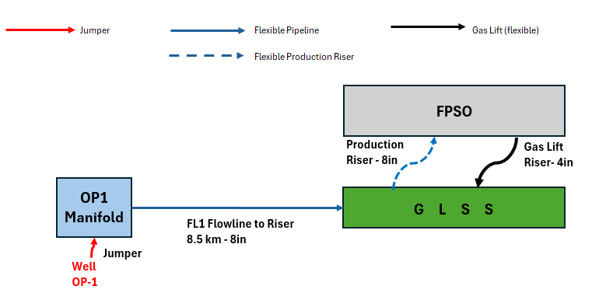
Figure 3-1 – EBAN Phase 1 Production System – Schematic
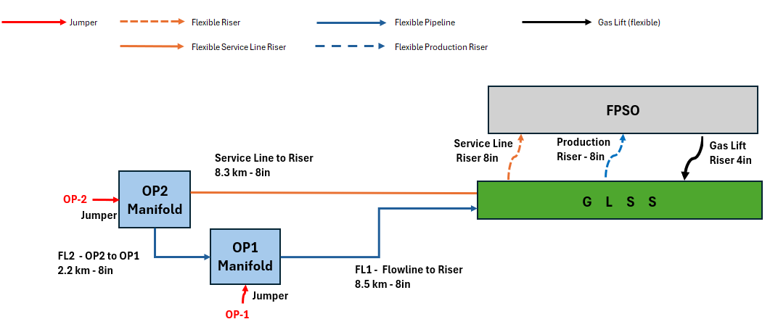
Figure 3-2 – EBAN Phase 2 Production System – Schematic
The system is designed to normally operate at 20 bara at topside receiving facilities, On the topside, the receiving riser is equipped with choke valve that could be used to mitigate typical operating issues such as slugging in turn down operations, or high velocity in the risers leading to higher frictional pressure drops and reduced deliverability.
High Level Line Sizing- Configuration Screening
With reference to Figure 3-1 and Figure 3-2, at the onset of the FEED analysis, the following alternative line sizes / gas lift configurations were considered:

- 8 inch line sizes with riser based gas lift
- 8 inch line size with OP1 PLET gas lift
- 6 inch line size with riser based gas lift
- 6 inch line size with OP1 PLET gas lift.

Option 4 was immediately discounted due to excessively high back pressure from pipeline size and increased gas flow rates from OP1 PLET.

Options 1 – 3 were considered and Option 1 was chosen as minimal productivity benefit was realised between the PLET gas lift versus riser based gas lift options, however Option 2 would require an extra flowline from FPSO to OP1 PLET

Riser based gas lift is the preferred option as it does not require an extra flowline and the 8 inch pipeline sized ensured high level screening deliverability targets through all production phases.

Option 1 is the preferred line size and gas lift configuration and is presented as such in the report. See Attachment 8.3 for further information.
Production Network – Deliverability
Figure 3-3 shows the Production profile for the EBAN field development to illustrate the variation of gas oil and water rates throughout field life. The production profile is defined in two phases based on the introduction of the service line, however from Flow Assurance analysis there are distinctively three phases corresponding to the amount of production. The figure illustrates the following:
- Phase 1 – 2029 and 2030 – 1 well producing (OP1) – Oil flowrate 4,500 bpd
- Phase 2 – 3031 to 2038 (inclusive) – 2 well production – Oil flowrate varies from 9000 to 7100 bpd
- Phase 3 – 2039 to 2051 (inclusive) – 1 well production (OP1 and OP2) – Oil flowrate varies from 4000 to 1900 bpd.
The figure also shows the gas and oil production follow similar trends, so the GOR essentially remains consistent through filed life. Peak water occurs in the last year, with water break out starting to increase from 2041 onwards during only OP2 production, resulting in a decrease in GLR from 2041 onwards.

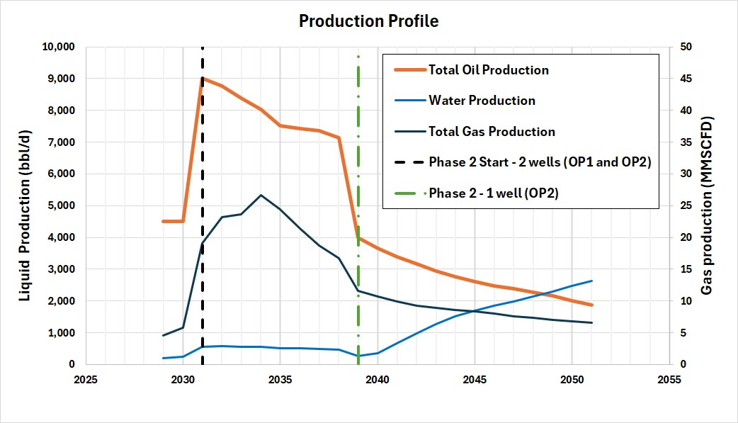
Figure 3-3 – Deliverability – Targeted Production Profiles
Figure 3-4 below presents deliverability targets versus achieved production The achieved results are based on the optimum gas lift requirement. In addition in Phase 1 Year 2029, topsides choking stabilises flow (See Section 5.8.1.3).

It is worth noting that there is ~ 1MMSCFD difference in produced gas between Years 2029 and 2030. This amount of gas has an impact on the difference in flow stability between 2029 and 2030, with 2029 requiring topsides choking while 2030 is more stable and thus not needing topsides choking. Attention should be given to the GLR ratio during this period of Phase 1 production to assist in flow stability management and topsides choking requirements.

Overall, the results show that the production targets can be met with the current optimised EBAN FEED design, however this is with the optimised gas lift amounts.

.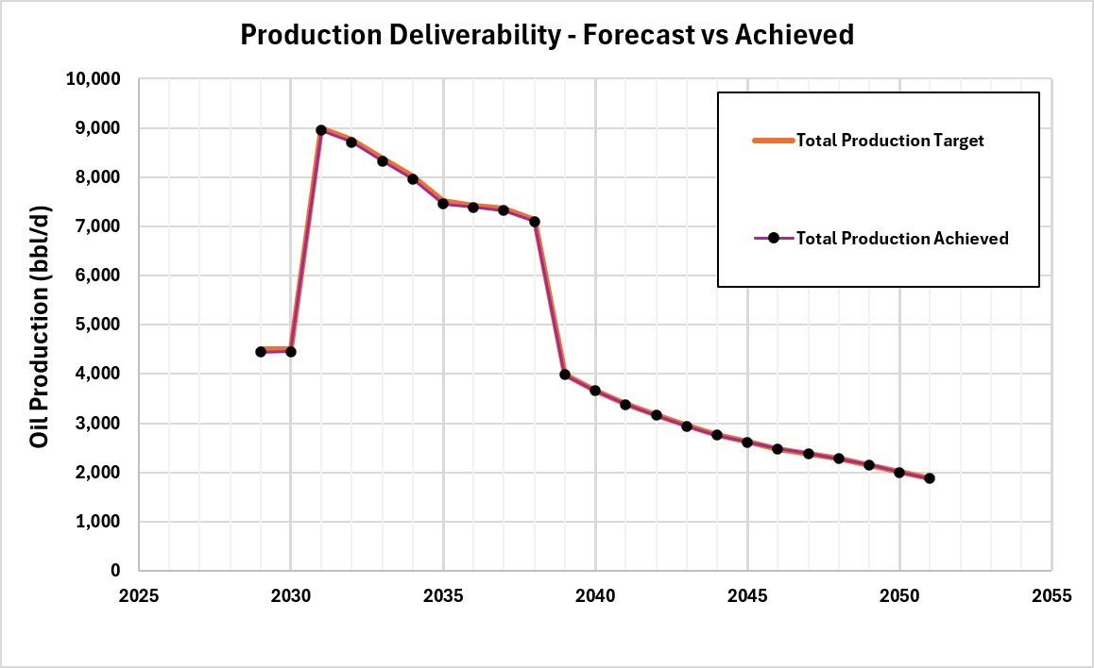
Figure 3-4 – Deliverability – Forecast versus Achieved
Figure 3-5 presents the riser based gas lift sensitivity study performed to achieve the production targets. The figure shows a range of riser based lift gas amounts between 0 and 20 MMSCFD. and illustrates the following:
- In Phase 1, 15 MMSCFD is sufficient to achieve the target deliverability.
- In early Phase 2, from 2031 to 2038 (inclusive), production targets are achieved without gas lift.
- In Phase 2, from 2039 to 2051, gas lift is required to achieve production targets. Optimisation of the gas lift amount required for the most effiicient use, ranging from 5 to 10MMSCFD.

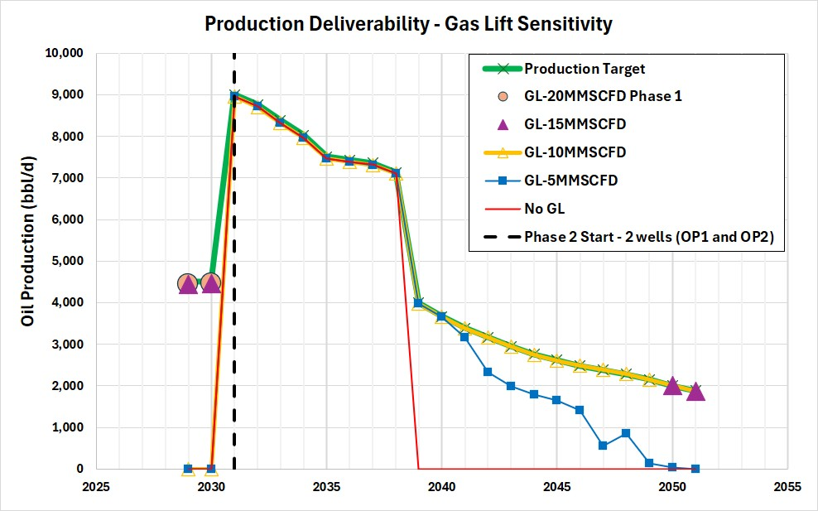
Figure 3-5 – Deliverability Achieved – Gas Lift Requirements

Production Network – Arrival Temperature
Figure 3-6 below shows the arrival temperature at the FPSO during normal operations. The arrival temperature varies between around 6 and 45 deg C. Late field life temperature is between 16 and 20 deg C with the increasing water cut considered to maintain the temperature when hydrocarbon rates have fallen during production tail off. The temperature follows the flowrate where the lowest temperatures are predicted during single well production and high temperatures occur during plateau flowrates. It should be noted that the low arrival temperature in Year 1 is due to topsides choking (See Section 5.8.1) alongside gas lift.
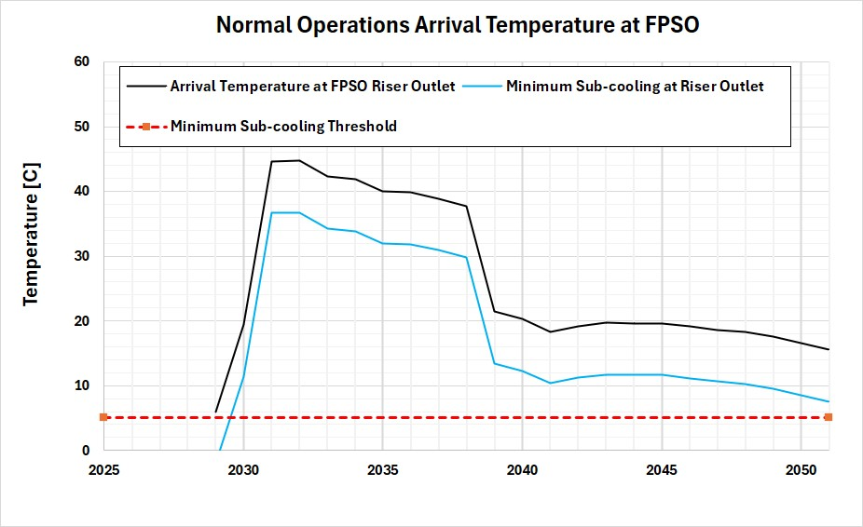
Figure 3-6 – Normal Operations Arrival Temperature at FPSO
Continuous MeOH Inhibition
In phase 1 due to the relatively colder arrival temperature and absence of the service line, continuous MeOH inhibition is required. Based on the worst case inhibition requirement, a packed shutdown and cool down to ambient conditions, 1 m3/hr of MeOH would be required continuously in phase 1.
It should be noted that the fluid arrival temperature is quite cold also in 2051 (last year of production) thus an insufficient cool down time is expected in this period also (to be discussed further in Operability report, Ref /7/). With the maximum water production observed in 2051 (See Figure 3-3) 5 m3/hr of MEOH is required for the packed cool down case in this year. This is considered the maximum continuous MeOH inhibition requirement and is within the capacity of the MP MeOH pumps (Ref /11/).
Continuous Wax / PPD Inhibition
From Table 5-6 it is shown that throughout life of field, the margin from the WAT, 39 deg C (Ref /6/) varies from being below the WAT to 6 deg C above the WAT (during peak flow). It is thus recommended to have continuous Wax / PPD inhibition throughout the life of field.
Production Network – Arrival Flowrates
- The Peak Actual Total Liquid arrival flowrate is 68 m3/h (2031),
- The Peak Actual Condensate arrival flowrate is 65 m3/h (2031)
- The Peak water arrival flowrate is 7 m3/h
All of the above flowrates are significantly within the spare capacity available for EBAN fluids.
Throughout field life the arrival flow is stable apart from 2029 (See Section 5.8.2), where topsides choking is proposed to enable the flow to be stable enough to not breach the capacity of the HP Separator. In this period the peak pressure differential across the choke vale is 26 bar (See Section 5.8.1.3)
Due to the high differential, there is JT cooling across the valve which is catered for as there is continuous MeOH injection in this period.

Production Network – Velocities and EVR
- The maximum gas velocity in the flowline FL1 is 7.4 m/s in Year 2035 also during two well production.
- The maximum gas velocity in FL2 is 4.4 m/s. FL2 only transport OP2 well production so the velocity is lower.
- A maximum gas velocity of 13.5 m/s occurs in the riser in Year 2034. In the same year the maximum liquid velocity of 8.8 m/s occurs in the riser.

- The maximum liquid velocity in the flowline FL1 is 2.9 m/s in Year 2034 also during two well production.
- The maximum liquid velocity in FL2 is 1.2 m/s. FL2 only transport OP2 well production so the velocity is lower.
- Maximum erosional velocity flowlines is 0.4 observed in Years 2032 to 2035, in FL1 when transporting flow of two wells.
- The maximum EVR in the riser is 0.4 in Years 2031 to 2036, also during two well production.

Gas Lift System
Figure 3-7 is the schematic for the riser base gas lift system. The gas lift system feeds gas lift from the FPSO via a dedicated riser and flowline of 4 in ID to the GLSS. The required pressure at the GLSS floats on the required pressure of Production at the GLSS for the gas lift.
Section 5.4.3 and 0 show the required gas lift rate is between 5 and 15 MMSCFD.
The pressure during steady state at the GLSS production side is between 30 and 40 bara, however the gas lift maximum pressure case is during start-up of the preserved flowline due to the liquid head of diesel in the line (105 bara at the GLSS). This is discussed in more detail in the Operability report (Ref /7/), however the steady state pressures and temperatures covering the full range of conditions is presented in this report.
Topsides gas lift take off is from the 1st stage compressor discharge after the cooler.

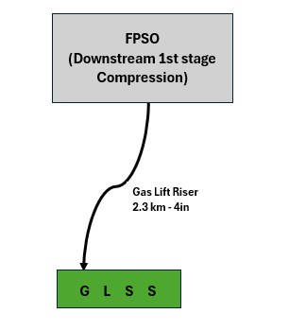
Figure 3-7 – EBAN Gas Lift System – Schematic
The deliverability analysis confirms that the EBAN production network requires between 5 and 15 MMSCFD through the life of field so peak flow is 15 MMSCFD in the 4in Gas lift riser.
The main outcomes of the analysis can be summarized as follows:
- The maximum required pressure in normal operating conditions is about 58 bara at the GLSS based on 15 MMSCFD
- The gas velocity within the distribution system is significantly within standard guidelines for velocity with maximum values being 17 m/s.
- During start-up from preservation, 105 bara is required at the GLSS, consequently the take off point will be downstream the 1st stage injection compressor cooler.
Water Injection System
Figure 3-8 shows the water injection system schematic. There is only one water injection well and the system has one dedicated riser, flowline and manifold for water injection. The target injection pressure at the wellhead ranges from 120.5 to 131 bara.
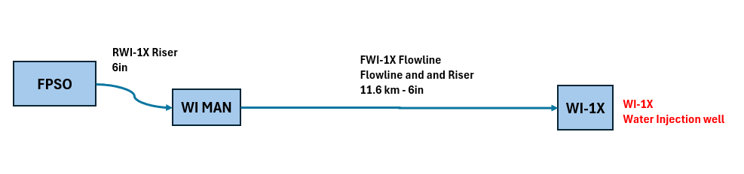
Figure 3-8 – EBAN Water Injection System – Schematic
For the whole water injection system, steady state analysis has been carried out to verify the topside pressure requirement along the asset life and any potential issue due to high velocity or EVR during steady conditions. The system has been modelled form topside to well-head of each injection well.
The main results can be summarized as follows:
- The flexible pipeline diameter of 6-inch ID is sufficient size to deliver the water requirements. The maximum discharge pressure requirement is about bara as reported in Table 3-1.
- Water velocity and EVR are within the minimum process design requirements.
- Maximum velocity of 1 m/s is observed in the dedicated WI riser and flowline up to the water injection well WI-1X (see Figure 3-8 above).

Case | Flowrate  [bbl/d] | Required Discharge Pressure  [bara] | Wellhead Pressure  [bara-] | Velocity Flowline Inlet  [m/s] | Velocity Flowline Outlet  [m/s] | Average Flowline  EVR  [-] | Temperature Inlet  [C] | Temperature  Outlet  [C]
Maximum  Flowrate | 10454 | 103 | 131 | 1.0 | 1.0 | 0.3 | 25 | 10
Minimum  Flowrate | 6497 | 96 | 131 | 0.7 | 0.7 | 0.2 | 25 | 7
Table 3-1 – Water Injection Outcomes – 6inch Maximum and Minimum Flows

BASIC DATA AND METHODOLOGY
For details of basic data and methodology applied for the analysis presented hereinafter, refer to Ref /6/, Flow Assurance Design Premise Report (351406BPRV20000)
PRODUCTION GATHERING NETWORK
Figure 5-1 and Figure 5-2 show simplified schematics for the Production system in Phase 1 and 2 respectively. In Phase 1, there is only one well OP1 connected to the FPSO via a dedicated flexible flowline and riser of 8 in ID via the GLSS (gas lift is mandatory in this scenario to achieve production targets).
Figure 5-1 – EBAN Phase 1 Production System – Schematic
In Phase 2 commencing two years after start of Phase 1, production is from two wells OP1 and OP2. In addition, a new service line of 8” ID provides a full preservation loop from FPSO. In latter years of Phase 2, there is only one well OP2, as OP1 ceases production earlier. The service line is still available and gas lift is mandatory for this period, to achieve production targets.
Figure 5-2 – EBAN Phase 2 Production System – Schematic
The system is designed to normally operate at 20 bara at topside receiving facilities, On the topside, the receiving riser is equipped with choke valve that could be used to mitigate typical operating issues such as slugging in turn down operations, or high velocity in the risers leading to higher frictional pressure drops and reduced deliverability.

High Level Production Line Sizing – Configuration Screening
With reference to Figure 3-1 and Figure 3-2, at the onset of the FEED analysis, the following alternative line sizes / gas lift configurations were considered:

- 8 inch line sizes with riser based gas lift
- 8 inch line size with OP1 PLET gas lift
- 6 inch line size with riser based gas lift
- 6 inch line size with OP1 PLET gas lift.

Option 4 was immediately discounted due to excessively high back pressure from pipeline size and increased gas flow rates from OP1 PLET.
Options 1 – 3 were considered and Option 1 was chosen as minimal productivity benefit was realised between the PLET gas lift versus riser based gas lift options, however Option 2 would require an extra flowline from FPSO to OP1 PLET
Riser based gas lift is the preferred option as it does not require an extra flowline and the 8 inch pipeline sized ensured high level screening deliverability targets through all production phases.
Option 1 is the preferred line size / riser based gas lift configuration and is presented as such in the report. See Attachment 8.3 for further information.
Steady State Analysis Basis
Steady state analyses have been conducted for the evaluation of the following aspects:
- Deliverability of Production targets
- Assessment of the pressure requirements
- Verification of the flow stability
- Assessment of the thermal performances (e.g. WAT potential, management and mitigation)
- Hydrates formation risk management.
Although most of the transportation system is not affected by seasonal effects from the thermal standpoint (deep water system), minimum ambient conditions (Ref./6/) have been used in the present study.
The analyses has been performed for the full life of field based on Production profiles provided in accordance with the Basis of Design (Ref./6/) For the configuration in this Flow Assurance study, the following parameters and relevant indicative limits have been considered (Ref./2/, /3/, /4/, /5/ and /6/):

- Thermo-Hydraulic Results. The main hydraulic results are reported with the following information:
  - Max EVR: 1 (C-factor C=135 (lb/ft/s²)^{1/2} for rigid lines and C=350 (lb/ft/s²)^{1/2} for flexible lines as per ref. /2/ and ref /5/.
  - Max gas velocity: 20 m/s;
  - Max liquid velocity: 5 m/s (if flow pattern is stratified/annular);
  - Flow regime (to avoid slugging);
  - Fluid Temperature at FPSO receiving above the WAT (Ref./6/)

- Hydrates risk. Since the WAT is higher than the hydrate formation temperature at the operating pressures (Ref./6/), hydrate risk is not a threat in steady state conditions as long as the system is designed to avoid wax deposition due to the insulation technology.
Feasibility analysis performed coupled with Contractor confirmation resulted in the following:
- Production line and service line – Flexibles with diameter 8 in (See Attachment 8.3)
- The Overall heat transfer coefficient – 4 W/m²K. This is applied to all components of the subsea system (i.e jumpers, spools, xmas trees)
In the next paragraph, the results and interpretations of the study are reported.
Deliverability Production Profiles
The following Figure 5-3 reports the production flowrates of field forecast for the EBAN FEED study (Ref /6/). These figures are provided as the variation of gas, oil and water rates through life of field show a strong correlation with different aspects of normal steady state thermal hydraulic analysis. In summary, it also shows the following:
- Period of Phase 1 – Only single well Production (OP1) – 2029 and 2030
- Period of Phase 2
  - Starting period of two well production – 2031 to 2038 (inclusive)
  - Period of Single well Production – 2039 to 2051 (inclusive)
The figure shows the following peak flowrates:
- Oil – 9000 bopd – at start of Phase 2 (Yr 2031)
- Gas – 27 MMSCFD (Yr 2034)
- Water – 2631 bwpd (Yr 2051)

Figure 5-4 shows the variation of gas – liquid ratio (GLR) throughout the life of field, without riser-based gas lift. It should be noted that the lowest GLR occurs in the first two years (Phase 1).
It should be noted that there is a 1-2 MMSCFD difference in gas associated gas in Phase 1 between 2029 and 2030. This is illustrated in both figures below, with the GLR showing a more significant upward gradient.

Figure 5-3 – EBAN FEED Production Profile Flowrates
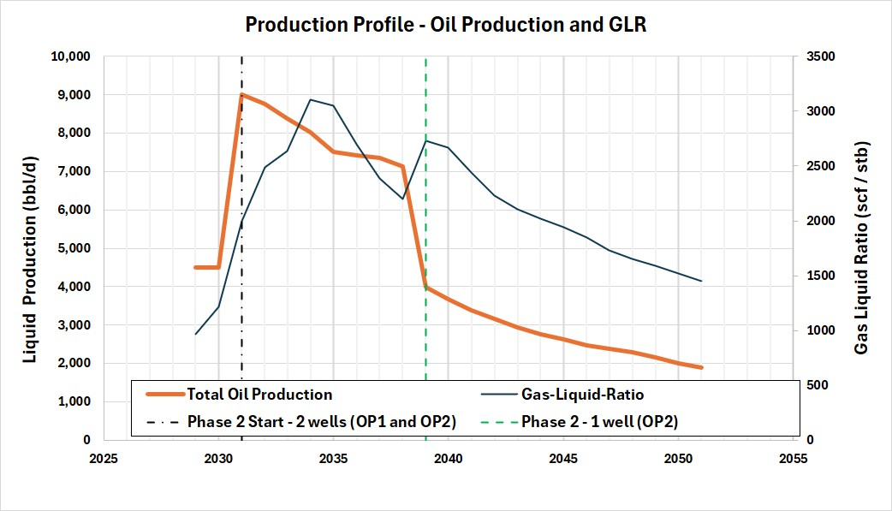
Figure 5-4 – EBAN FEED – Production profile- Gas Liquid Ratio Variation – Life of field

Deliverability Results
Overall Deliverability
Table 5-1 below lists the overall field deliverability both in terms of absolute and percentage loss values. The following points should be noted:
- In Phase 1 15 MMSCFD achieves the target deliverability.
- In early Phase 2, from 2031 to 2038 (inclusive), no gas lift is required.
- In Phase 2, from 2039 to 2051, between 5 and 10MMSCFD is required to achieve target deliverability.
 | Overall Oil Production  Forecast | Overall Oil Production  Achieved | Overall Production Achieved | Gas Lift Requirement
 | [STB/D] | [STB/D] | [%] | [MMSCFD]
2029 | 4500 | 4500 | 100% | 15
2030 | 4500 | 4500 | 100% | 15
2031 | 9000 | 9000 | 100% | 0
2032 | 8762 | 8762 | 100% | 0
2033 | 8383 | 8383 | 100% | 0
2034 | 8023 | 8023 | 100% | 0
2035 | 7509 | 7509 | 100% | 0
2036 | 7430 | 7430 | 100% | 0
2037 | 7364 | 7364 | 100% | 0
2038 | 7136 | 7136 | 100% | 0
2039 | 3990 | 3990 | 100% | 5
2040 | 3665 | 3665 | 100% | 5
2041 | 3388 | 3388 | 100% | 10
2042 | 3168 | 3168 | 100% | 10
2043 | 2943 | 2943 | 100% | 10
2044 | 2759 | 2759 | 100% | 10
2045 | 2618 | 2618 | 100% | 10
2046 | 2480 | 2480 | 100% | 10
2047 | 2384 | 2384 | 100% | 10
2048 | 2285 | 2285 | 100% | 10
2049 | 2155 | 2155 | 100% | 10
2050 | 2004 | 2004 | 100% | 10
2051 | 1880 | 1880 | 100% | 10
Table 5-1 – Overall Field Deliverability Results

In the table above, Year 2029 utilises topsides choking to achieve flow stability (See Section 5.8.1.3). It is worth noting that there is ~ 1MMSCFD difference in produced gas between Years 2029 and 2030. This amount of gas has an impact on the difference in flow stability between 2029 and 2030, with 2029 requiring topsides choking while 2030 is more stable and thus not requiring topsides choking. Attention should be given to the GLR ratio during this period of Phase 1 production to assist in flow stability management and topsides choking requirements.

Figure 5-5 below shows the results for the table above as a figure. The results show that the configuration along with optimised gas lift achieves the target production throughout the life of field.

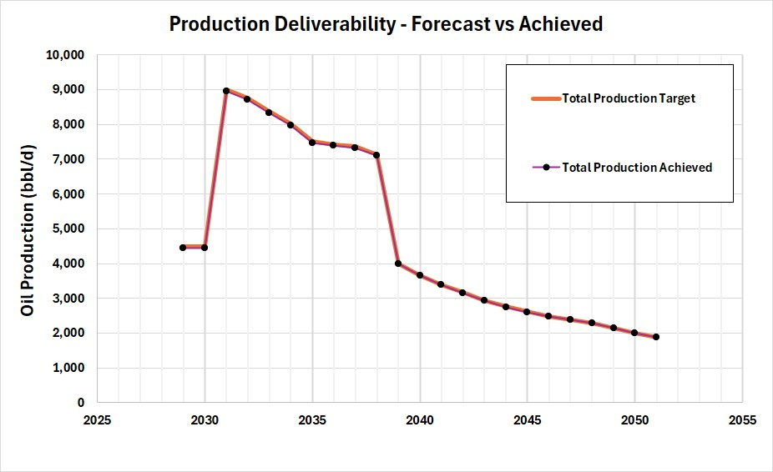
Figure 5-5 – Achieved Production versus Target Production Flowrate

Well by well Deliverability
Table 5-2 below shows the deliverability versus target flowrates on a well by well basis. Well OP1 produces from 2029 to 2038 and meets deliverability targets. Well OP2 produces from 2031 to 2051, also achieves targets.
 | Production Achieved  [STB/D] |  |  | Production Forecast  [STB/D] |  |  | Percentage of Forecast Achieved  [%]
 | OP1 | OP2 | Total | OP1 | OP2 | Total | OP1 | OP2 | Total
2029 | 4500 | - | 4500 | 4500 | - | 4500 | 100% | - | 100%
2030 | 4500 | - | 4500 | 4500 | - | 4500 | 100% | - | 100%
2031 | 4500 | 4500 | 9000 | 4500 | 4500 | 9000 | 100% | 100% | 100%
2032 | 4500 | 4262 | 8762 | 4500 | 4262 | 8762 | 100% | 100% | 100%
2033 | 4500 | 3883 | 8383 | 4500 | 3883 | 8383 | 100% | 100% | 100%
2034 | 4500 | 3523 | 8023 | 4500 | 3523 | 8023 | 100% | 100% | 100%
2035 | 3432 | 4077 | 7509 | 3432 | 4077 | 7509 | 100% | 100% | 100%
2036 | 3117 | 4313 | 7430 | 3117 | 4313 | 7430 | 100% | 100% | 100%
2037 | 3198 | 4165 | 7364 | 3198 | 4165 | 7364 | 100% | 100% | 100%
2038 | 3175 | 3961 | 7136 | 3175 | 3961 | 7136 | 100% | 100% | 100%
2039 | - | 3990 | 3990 | - | 3990 | 3990 | - | 100% | 100%
2040 | - | 3665 | 3665 | - | 3665 | 3665 | - | 100% | 100%
2041 | - | 3388 | 3388 | - | 3388 | 3388 | - | 100% | 100%
2042 | - | 3168 | 3168 | - | 3168 | 3168 | - | 100% | 100%
2043 | - | 2943 | 2943 | - | 2943 | 2943 | - | 100% | 100%
2044 | - | 2759 | 2759 | - | 2759 | 2759 | - | 100% | 100%
2045 | - | 2618 | 2618 | - | 2618 | 2618 | - | 100% | 100%
2046 | - | 2480 | 2480 | - | 2480 | 2480 | - | 100% | 100%
2047 | - | 2384 | 2384 | - | 2384 | 2384 | - | 100% | 100%
2048 | - | 2285 | 2285 | - | 2285 | 2285 | - | 100% | 100%
2049 | - | 2155 | 2155 | - | 2155 | 2155 | - | 100% | 100%
2050 | - | 2004 | 2004 | - | 2004 | 2004 | - | 100% | 100%
2051 | - | 1880 | 1880 | - | 1880 | 1880 | - | 100% | 100%
Table 5-2 – Individual Well Deliverability Results

Gas Lift Sensitivity
The achieved flowrates presented in Sections 5.4.1 and 5.4.2 are based on the optimised gas lift from analysis. This section presents the impact of production with and without gas lift.
The figure below shows achieved production for a range of gas lift values between 0 and 20MMSCFD. The results show the following:
- Phase 1 – with only OP1 producing requires 15 MMSCFD of gas lift. There is limited increased production with 20 MMSCFD.
- In early Phase 2, from 2031 to 2038 (inclusive), production targets are achieved without gas lift.
- In Phase 2 from 2039 to 2051 production becomes single well production and gas lift is required to achieve production targets.
  - In 2039 and 2040, 5 MMSCFD is sufficient to meet production targets and limited increase in production with more gas lift.
  - From 2041 to end of field life, 10 MMSCFD is required to meet gas production targets 5MMSCFD is not sufficient. 15 MMSCFD provides minimal increase in production compared to 10 MMSCFD gas lift.
With reference to Figure 5-4 which shows the variation of gas liquid ratio over field life, it should be noted that Phase 1 with the lowest GLR requires the highest amount of gas lift.
In addition the two years at the start of single well production (2039 and 2040), only need 5 MMSCFD and they also show high GLRs relative to the rest of Phase 2 production to the end of field life.

Figure 5-6 – Achieved Production and Various Gas lift Flowrates

Subsea - Pressures and Temperatures
The conditions upstream and downstream of the subsea production choke are listed in Table 5-3 and Table 5-4 for pressures and temperatures respectively. The maximum pressure upstream and downstream the choke is 164 and 60 bara respectively. Downstream pressures for Well OP2 tend to be higher than OP1 due to the longer distance to the FPSO.

The maximum temperature upstream and downstream the subsea choke is 93 and 86 deg C respectively. The minimum temperature upstream and downstream the subsea chokes are 84 and 79 deg C respectively.

Year | Pressure (bara)
Year | OP1 |  | OP2
Year | Upstream | Downstream | Upstream | Downstream
2029 | 164 | 37 | - | -
2030 | 156 | 37 | - | -
2031 | 157 | 50 | 121 | 54
2032 | 145 | 54 | 92 | 58
2033 | 128 | 53 | 89 | 57
2034 | 100 | 56 | 93 | 60
2035 | 91 | 53 | 88 | 57
2036 | 87 | 49 | 83 | 53
2037 | 81 | 46 | 79 | 50
2038 | 75 | 44 | 76 | 48
2039 | - | - | 61 | 40
2040 | - | - | 59 | 40
2041 | - | - | 58 | 40
2042 | - | - | 57 | 40
2043 | - | - | 58 | 40
2044 | - | - | 59 | 40
2045 | - | - | 60 | 39
2046 | - | - | 60 | 39
2047 | - | - | 61 | 39
2048 | - | - | 62 | 39
2049 | - | - | 63 | 38
2050 | - | - | 64 | 38
2051 | - | - | 66 | 38
Table 5-3 – Subsea Pressures Upstream and Downstream Choke

 | Temperature (deg C)
 | OP1 |  | OP2
 | Upstream | Downstream | Upstream | Downstream
2029 | 88 | 84 | - | -
2030 | 90 | 86 | - | -
2031 | 93 | 86 | 91 | 86
2032 | 92 | 85 | 90 | 86
2033 | 90 | 82 | 87 | 84
2034 | 88 | 82 | 86 | 83
2035 | 86 | 79 | 88 | 85
2036 | 85 | 79 | 89 | 86
2037 | 84 | 80 | 88 | 84
2038 | 84 | 80 | 87 | 84
2039 | - | - | 87 | 84
2040 | - | - | 87 | 84
2041 | - | - | 88 | 85
2042 | - | - | 88 | 86
2043 | - | - | 89 | 87
2044 | - | - | 89 | 87
2045 | - | - | 89 | 87
2046 | - | - | 89 | 87
2047 | - | - | 89 | 87
2048 | - | - | 89 | 86
2049 | - | - | 89 | 86
2050 | - | - | 88 | 85
2051 | - | - | 88 | 85
Table 5-4 – Subsea Temperatures Upstream and Downstream of Choke
Flowline – Pressure and Temperature Profiles
Pressure Profiles
This section shows the maximum and minimum steady state pressure and temperature profiles in the flowlines.
Figure 5-7 and Figure 5-8 show the maximum and minimum pressure profiles in flowlines FL2 and FL1 respectively. The profile shows the maximum inlet pressure into FL2 is 60 bara which occurs in Year 2034. This also coincides with the value in Table 5-3. The minimum pressure in FL2 occurs in 2051, the year with least flow and the minimum inlet pressure is 38 bara.
The maximum inlet pressure into FL1 is observed in 2034 with a value of 56 bara and the minimum inlet pressure into FL1 is 34 bara which occurs in Year 2051.

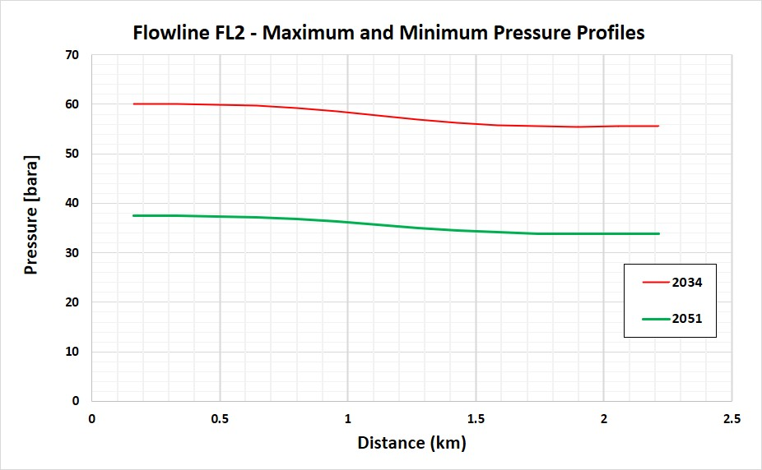
Figure 5-7 – Flowline FL2 – Maximum and Minimum pressure profiles

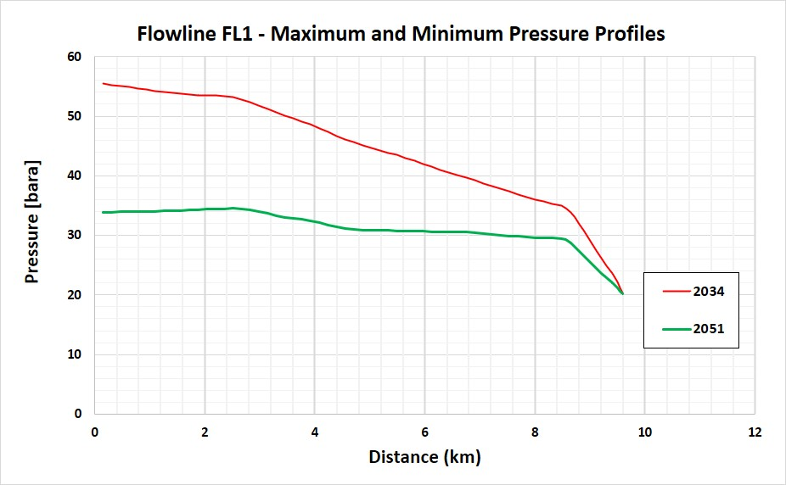
Figure 5-8 – Flowline FL1 – Maximum and Minimum pressure profiles
Temperature Profiles
Figure 5-9 and Figure 5-10 show the maximum and minimum temperature profiles in flowlines FL2 and FL1 respectively. The profile shows the maximum inlet temperature into FL2 is 86 deg C which occurs in Year 2045. This also aligns with the value in Table 5-4. The minimum temperature in FL2 occurs in 2034, due to the lowest inlet temperature into the flowline (See Table 5-4.)
The maximum inlet temperature into FL1 is observed in 2030 with a value of 84 deg C, however due to that year being a single well production period a higher FL1 outlet temperature of 45 deg C occurs in 2031 with two well production.
The minimum inlet temperature into FL1 is 66 deg C which occurs in Year 2051 and the same year with minimum flow results in the minimum pipeline exit temperature of 16 deg C. It should be noted that in 2029, the FL1 exit temperature is also low as discussed in Section 5.8.1

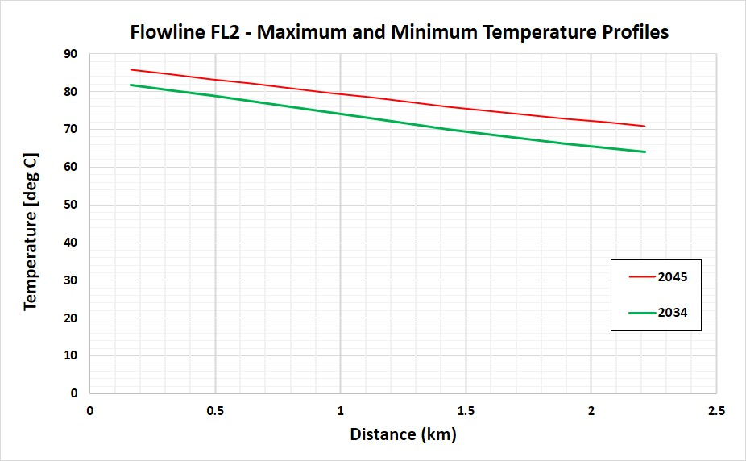
Figure 5-9 – Flowline FL2 – Maximum and Minimum Temperature profiles

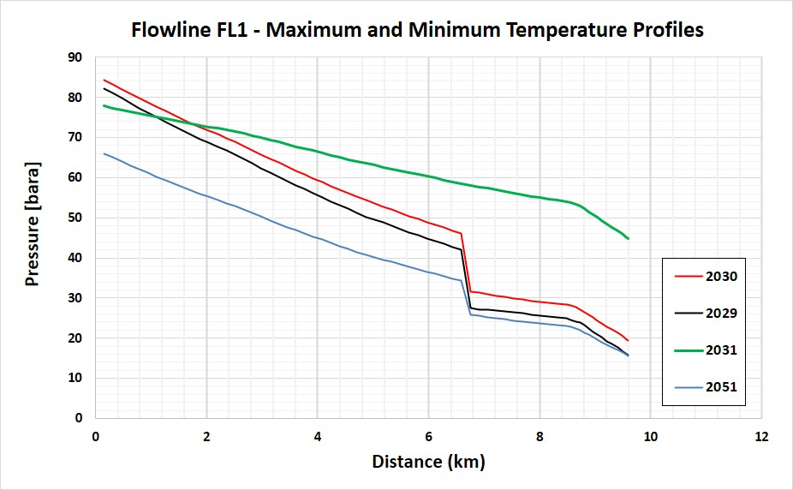
Figure 5-10 – Flowline FL1 – Maximum and Minimum Temperature profiles
EVR, Fluid Velocities and Pressure Drops
The velocities and erosional velocity ratios in the pipeline during steady state are presented for the life of field in Table 5-5 below. The results are as follows:
- Maximum erosional velocity flowlines is 0.4 observed in Years 2032 to 2035, in FL1 when transporting flow of two wells.
- The maximum EVR in the riser is 0.4 in Years 2031 to 2036, also during two well production.
- The maximum gas velocity in the flowline FL1 is 7.4 m/s in Year 2035 also during two well production.
- The maximum gas velocity in FL2 is 4.4 m/s. FL2 only transport OP2 well production so the velocity is lower.
- A maximum gas velocity of 13.5 m/s occurs in the riser in Year 2034. In the same year the maximum liquid velocity of 8.8 m/s occurs in the riser.
- The maximum liquid velocity in the flowline FL1 is 2.9 m/s in Year 2034 also during two well production.
- The maximum liquid velocity in FL2 is 1.2 m/s. FL2 only transport OP2 well production so the velocity is lower.

 | Erosional Velocity Ratio  [-] |  | Gas Velocity  [m/s] |  | Liquid Velocity  [m/s] |  | Erosional Velocity Ratio  [-] | Gas Velocity  [m/s] | Liquid Velocity  [m/s]
 | FL1 | FL2 | FL1 | FL2 | FL1 | FL2 | Riser | Riser | Riser
2029 | 0.1 | - | 2.5 | - | 2.0 | - | 0.3 | 10.4 | 4.7
2030 | 0.1 | - | 2.8 | - | 2.1 | - | 0.3 | 10.4 | 5.1
2031 | 0.3 | 0.2 | 6.3 | 3.1 | 2.6 | 0.9 | 0.4 | 9.9 | 7.0
2032 | 0.4 | 0.2 | 7.1 | 3.3 | 2.8 | 0.9 | 0.4 | 12.0 | 8.2
2033 | 0.4 | 0.1 | 7.2 | 2.7 | 2.8 | 0.7 | 0.4 | 12.1 | 8.1
2034 | 0.4 | 0.1 | 7.3 | 2.0 | 2.9 | 0.5 | 0.4 | 13.5 | 8.8
2035 | 0.4 | 0.1 | 7.4 | 2.3 | 2.7 | 0.6 | 0.4 | 12.4 | 7.9
2036 | 0.3 | 0.1 | 6.9 | 2.7 | 2.5 | 0.7 | 0.4 | 11.0 | 7.0
2037 | 0.3 | 0.2 | 6.3 | 3.2 | 2.4 | 0.9 | 0.3 | 9.6 | 6.2
2038 | 0.3 | 0.2 | 5.8 | 3.4 | 2.3 | 0.9 | 0.3 | 8.6 | 5.5
2039 | 0.2 | 0.2 | 4.5 | 4.4 | 1.8 | 1.2 | 0.3 | 8.2 | 3.8
2040 | 0.2 | 0.2 | 4.3 | 4.2 | 1.7 | 1.1 | 0.3 | 7.8 | 3.5
2041 | 0.2 | 0.2 | 4.0 | 3.9 | 2.0 | 0.9 | 0.3 | 9.8 | 4.3
2042 | 0.2 | 0.2 | 3.8 | 3.8 | 1.9 | 0.9 | 0.3 | 9.5 | 4.1
2043 | 0.2 | 0.2 | 3.8 | 3.7 | 1.9 | 0.8 | 0.3 | 9.4 | 4.0
2044 | 0.2 | 0.2 | 3.7 | 3.6 | 1.9 | 0.8 | 0.3 | 9.3 | 3.9
2045 | 0.2 | 0.2 | 3.6 | 3.6 | 1.8 | 0.8 | 0.3 | 9.1 | 3.8
2046 | 0.2 | 0.2 | 3.5 | 3.5 | 1.8 | 0.7 | 0.3 | 8.9 | 3.6
2047 | 0.2 | 0.2 | 3.4 | 3.4 | 1.8 | 0.7 | 0.3 | 8.7 | 3.5
2048 | 0.2 | 0.2 | 3.3 | 3.3 | 1.7 | 0.7 | 0.3 | 8.6 | 3.4
2049 | 0.1 | 0.1 | 3.3 | 3.2 | 1.7 | 0.6 | 0.3 | 8.5 | 3.2
2050 | 0.1 | 0.1 | 3.2 | 3.2 | 1.7 | 0.6 | 0.3 | 8.3 | 3.1
2051 | 0.1 | 0.1 | 3.1 | 3.1 | 1.6 | 0.5 | 0.3 | 8.2 | 2.9
Table 5-5 – Pipeline Velocities

Arrival Conditions
Arrival Temperatures
Table 5-6 below lists the arrival temperatures at the FPSO during steady state operations for the life of field. The results show a correlation between amount of flow and the arrival temperature.

 | Arrival Temperature d/s topside choke | Minimum sub-cooling in pipeline
2029 | 6 | -2
2030 | 19 | 11
2031 | 45 | 37
2032 | 45 | 37
2033 | 42 | 34
2034 | 42 | 34
2035 | 40 | 32
2036 | 40 | 32
2037 | 39 | 31
2038 | 38 | 30
2039 | 21 | 13
2040 | 20 | 12
2041 | 18 | 10
2042 | 19 | 11
2043 | 20 | 12
2044 | 20 | 12
2045 | 20 | 12
2046 | 19 | 11
2047 | 19 | 11
2048 | 18 | 10
2049 | 18 | 10
2050 | 17 | 9
2051 | 16 | 8
Table 5-6 – FPSO Arrival Temperatures and Pipeline Minimum sub-cooling – Steady State

Figure 5-11 illustrates the predicted FPSO arrival temperatures during the life of field of the EBAN development shown in the table above. The figure shows that the arrival temperature follows the trend of production flowrate where the lowest temperatures are predicted during single well production and high temperatures occur during plateau flowrates, as follows:
Phase 1 - 2029 and 2030 the arrival temperature is 6 and 19 deg C respectively (Topsides choking is required in 2029 and so the temperature downstream the topsides choke valve falls to 6 deg C, see Figure 5-14). Early Phase 2 - 2030 to 2038 (inclusive), the arrival temperature is between 45 and 38 deg C and minimum sub-cooling between 37 and 30 deg C.
Late Phase 2 – 2039 to 2051, with one well production, the arrival temperature is between 21 and 16 deg C. It should be noted that there is less flow in 2051 than 2029, however there is a considerably higher water cut causing equivalent
Figure 5-11 – Normal Operations Arrival Temperatures

Sections 5.8.1.1 and 5.8.1.2 elaborate on the consequences of the arrival temperatures listed above with respect to hydrate and wax risk mitigation.
Continuous Hydrate Inhibition
The arrival temperatures shown in Table 5-6 and Figure 5-11 show lower temperatures in the first two years when the service line is not available. Continuous hydrate inhibition is thus proposed to keep the production fluids outside the hydrate formation temperature in both steady state and worst case upset scenarios.
Methanol is the proposed THI and the amount of injection has to be sufficient to provide hydrate inhibition at well shut in conditions and ambient temperature, to ensure infinite cool down time (detailed analysis CDTs will be provided in the Operability report Ref /7/.
The figure below shows hydrate curves for the production fluid with various amounts of hydrate inhibition and the shut-in pressure / ambient conditions PT point. Considering the point shown in the figure a rate of 0.42 kg MEOH / kg produced water, will provide sufficient MEOH to cater for the shut-in scenario at ambient conditions. From the production profile produced water, peak requirement would be 0.53 m³/h in year 2030.
Consideration is given to the period with the highest produced water. 2051. In this period the packed settle out pressure is around 80 bara, 0.33 kg MEOH / kg produced water is required leading to a peak requirement of 5.1 m3/h, to provide infinite cool down time from continuous MeOH inhibition (see Operability report for further details, Ref /7/). This is within the capacity of the MP MeOH pumps (Ref /11/).
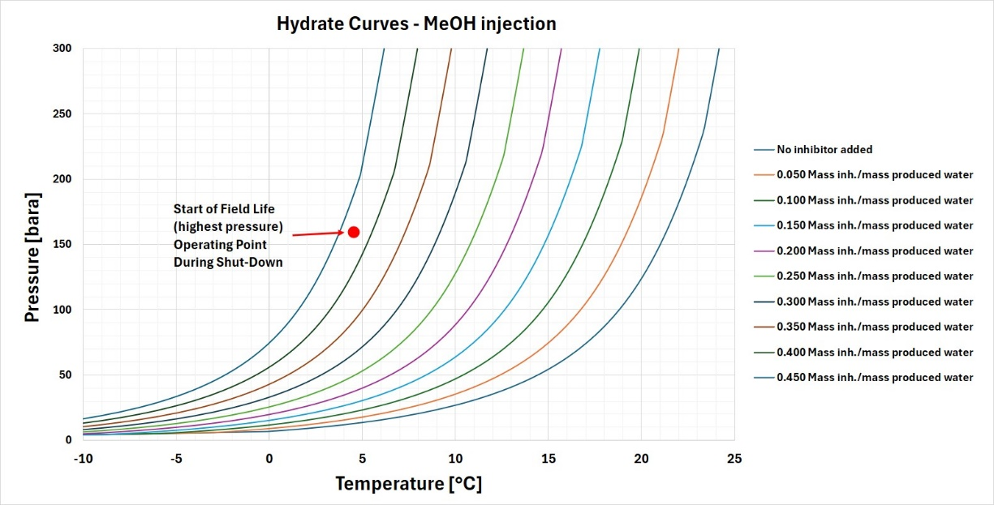
Figure 5-12 – Hydrate Curves with and without MEOH Inhibition
Continuous Wax / PPD Inhibition
From Table 5-6 it is shown that in all single well production cases the arrival temperature is below the WAT, 39 deg C (Ref /6/). In addition, even during two well production periods, the margin from WAT varies between 0 and 6 deg C. It is thus recommended to have continuous Wax / PPD inhibition throughout life of field.
Topsides Choking Impact – Pressure and Temperature
As stated in Section 5.4 and Section 3.1.2, in Phase 1 topsides choking can stabilize flow alongside gas lift.
Figure 5-14 shows the impact of topsides choking on the arrival temperature. The results showing arrival temperature in Year 1 with and without topsides choking, show a reduction in temperature of around 7 deg C due to temperature drop across the topsides choke valve.

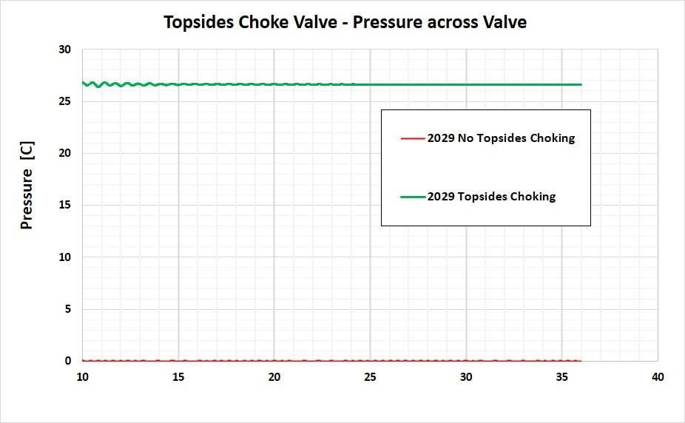
Figure 5-13 –Topsides Choking – Pressure drop across Choke Valve

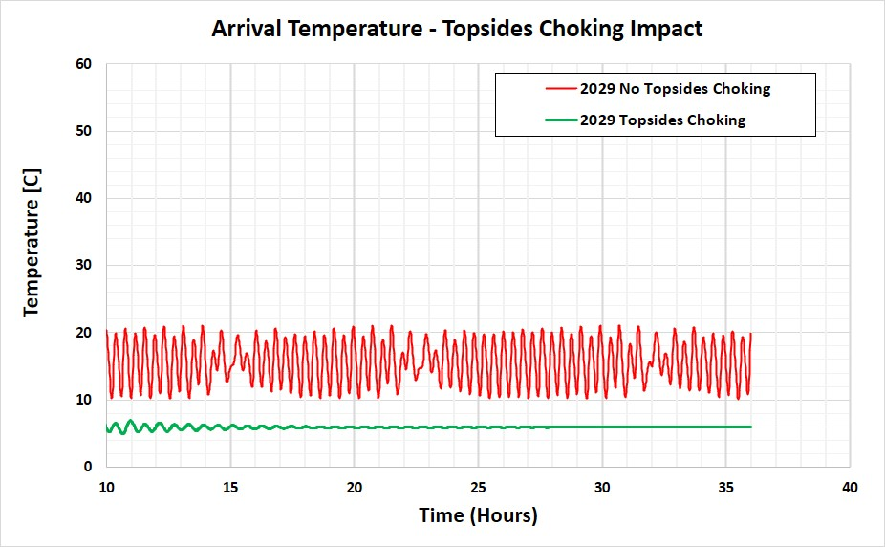
Figure 5-14 – Impact of Topsides Choking on Arrival Temperature
Topsides Choking on Flow Stability
Figure 5-15 illustrates the impact of topsides choking on stabilizing the flowrate. Results show that although without choking the arrival flowrates are within the capacity of the receiving vessel (capacity available > 20,000 BPD, Ref /6/, the flow is not stable. Topsides choking enables closer flow to the targeted production.
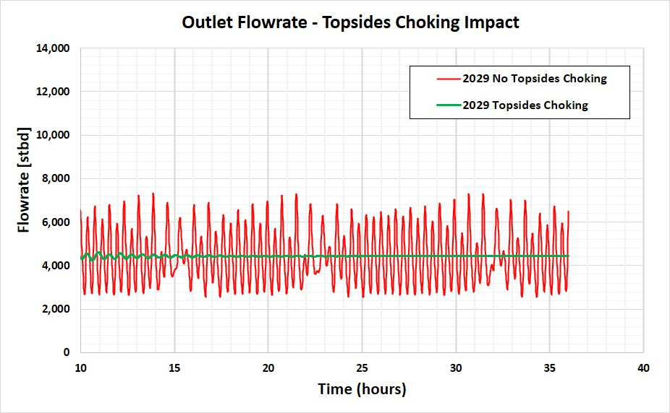
Figure 5-15 – Impact of Topsides Choking on Outlet Flowrate
Arrival Actual Flowrates and Flow Stability
Table 5-7 below shows the arrival flowrates at the FPSO in actual conditions. It should be noted that there is sufficient capacity in the receiving HP separator for the flowrates of all the phases (Ref /9/).
The HP Separator has a name plate liquid handling capacity of 58,000 bbl/d and is currently processing between 20 and 30,000 bbl/d and an associated gas capacity of 200MMSCFD (Ref /8/ and /13/)
Values are also provided for PinSpan which provides information on flow stability in terms of variation of back pressure at pipeline inlet at steady state. All the values are 0, however in Year 2029 topsides choking is required to achieve flow stability and the zero PinSpan value. Section 5.8.1.4 explains the reason behind the flow instability and the mitigating measures possible through topsides choking.
 | Liquid Rate |  | Oil Rate |  | Water Rate |  | Gas Rate |  | PinSpan
 | [m3/h] | bpd | [m3/h] | bpd | [m3/h] | bpd | [m3/h] | [MMSCFD] | [bar]
2029 | 33 | 5015 | 32 | 4775 | 2 | 230 | 1137 | 20 | 0.0
2030 | 35 | 5315 | 33 | 5006 | 2 | 315 | 1147 | 21 | 0.0
2031 | 68 | 10309 | 65 | 9787 | 4 | 530 | 1057 | 19 | 0.0
2032 | 67 | 10135 | 64 | 9597 | 4 | 550 | 1299 | 23 | 0.0
2033 | 64 | 9717 | 61 | 9195 | 4 | 529 | 1316 | 24 | 0.0
2034 | 62 | 9364 | 59 | 8853 | 3 | 517 | 1484 | 26 | 0.0
2035 | 58 | 8772 | 55 | 8304 | 3 | 479 | 1357 | 24 | 0.0
2036 | 57 | 8653 | 54 | 8184 | 3 | 477 | 1189 | 21 | 0.0
2037 | 57 | 8550 | 54 | 8092 | 3 | 468 | 1028 | 19 | 0.0
2038 | 55 | 8246 | 52 | 7809 | 3 | 446 | 918 | 17 | 0.0
2039 | 32 | 4777 | 30 | 4530 | 2 | 253 | 890 | 17 | 0.0
2040 | 30 | 4499 | 28 | 4172 | 2 | 333 | 842 | 16 | 0.0
2041 | 30 | 4469 | 26 | 3921 | 4 | 553 | 1075 | 20 | 0.0
2042 | 29 | 4410 | 24 | 3670 | 5 | 745 | 1046 | 19 | 0.0
2043 | 29 | 4303 | 23 | 3418 | 6 | 890 | 1032 | 19 | 0.0
2044 | 28 | 4182 | 21 | 3214 | 6 | 972 | 1020 | 19 | 0.0
2045 | 27 | 4101 | 20 | 3079 | 7 | 1027 | 998 | 18 | 0.0
2046 | 26 | 3982 | 19 | 2926 | 7 | 1060 | 978 | 18 | 0.0
2047 | 26 | 3898 | 19 | 2818 | 7 | 1084 | 954 | 18 | 0.0
2048 | 25 | 3808 | 18 | 2708 | 7 | 1104 | 941 | 17 | 0.0
2049 | 24 | 3672 | 17 | 2566 | 7 | 1111 | 926 | 17 | 0.0
2050 | 23 | 3503 | 16 | 2400 | 7 | 1106 | 911 | 17 | 0.0
2051 | 22 | 3354 | 15 | 2265 | 7 | 1093 | 895 | 17 | 0.1
Table 5-7 – FPSO Arrival Flowrates - Steady State
RESULTS – GAS LIFT SYSTEM
Figure 6-1 is the schematic for the riser base gas lift system. The gas lift system feeds gas lift from the FPSO via a dedicated flexible riser and flexible flowline to the GLSS. The required pressure of gas lift at the GLSS floats on the required pressure in the Production flowline.
Figure 6-1 – EBAN Gas Lift System – Schematic
Gas Lift Requirements
Section 5.4.3 shows the required gas lift rate is between 5 and 15 MMSCFD.
The pressure during steady state at the GLSS production side is between 30 and 40 bara, however the gas lift maximum pressure case is during start-up of the preserved flowline due to the liquid head of diesel in the line (105 bara at the GLSS). This is discussed in more detail in the Operability report (Ref /7/), however the steady state pressures and temperatures covering the full range of conditions is presented in this report.
Topsides gas lift take off is from the 1st stage compressor discharge after the cooler. The riser and flowline are sized at 4in internal diameter and a range of gas lift flowrates (5, 10 and 15 MMSCFD) are considered for the analysis.
Gas Lift Steady State Results
Table 6-1 below lists the results of the steady state analysis for the gas lift system for flowrates between 5 and 15 MMSCFD and floating on the production pressure at the GLSS of 30 and 40 bara. The results show that to deliver the maximum gas lift requirement of 15MMSCFD to Production at the GLSS of 40 bara, 58 bara is required.
In addition the minimum flowrate of 5 MMSCFD to deliver at the Production GLSS a pressure of 30 bara, 32 bara discharge pressure is required.
In most of the cases the arrival temperature at the GLSS is around 4-5 degC. The high velocity case where 15 MMSCFD is delivered to the GLSS at 30 bara, results in a velocity of 17 m/s, and some JT cooling such that the temperature at the GLSS is 1 degC.
Case | Gas Lift Flowrate  (MMSCFD) | Required Discharge Pressure  (bara) | Max Pressure GLSS  (bara) | Velocity at Inlet  (m/s) | Velocity at Outlet  (m/s) | Temperature at Inlet [C] | Temperature at GLSS [C]
Maximum  Flowrate  40 bara | 15 | 58 | 40 | 9 | 12 | 33 | 5
Maximum Flowrate  30 bara | 15 | 54 | 30 | 11 | 17 | 33 | 1
- | 10 | 48 | 40 | 8 | 9 | 33 | 4
Minimum Flowrate | 5 | 40 | 40 | 5 | 4 | 33 | 5
Minimum  Flowrate  30 bara | 5 | 32 | 30 | 6 | 6 | 33 | 5
Table 6-1 – Gas Lift Outcomes – 4inch Maximum and Minimum Steady State Flow

Table 6-2 below presents the following other cases:
- The start-up case - To provide 105 bara at the GLSS after preservation (Ref /7/) – Requiring a discharge pressure of 105 bara. It should be noted that such a discharge pressure is available at the 1st stage Injection compressor (Ref /10/)

- Two cases with 20 MMSCFD gas lift – The results show that 20MMSCFD to a pressure of 30 bara results in a velocity above 20m/s. However, 20 MMSCFD is larger than the gas lift requirements.

Case | Gas Lift Flowrate  (MMSCFD) | Required Discharge Pressure  (bara) | Max Pressure at GLSS  (bara) | Velocity at Inlet  (m/s) | Velocity at Outlet  (m/s) | Temperature at Inlet [C] | Temperature at GLSS [C]
Start-up case  Maximum flowrate | 15 | 105 | 105 | 105 | 5 | 5 | 4
Sensitivity at 20MMSCFD  High Pressure | 20 | 70 | 40 | 10 | 16 | 33 | 4
Sensitivity at 20MMSCFD  Low Pressure | 20 | 66 | 30 | 11 | 22 | 33 | 1
Table 6-2 – Gas Lift Other Cases – 4inch Maximum and Minimum Steady State Flow

Figure 6-2 and Figure 6-3 illustrate the results in the above tables, showing discharge pressure requirement and velocity versus gas flowrate respectively. Figure 6-2 shows that there is sufficient pressure at the 1st stage injection compressor to provide gas lift during start-up. However further upstream (i.e. downstream of dehydration) there is insufficient pressure (66 bara, Ref /10/).

Figure 6-3 shows that 20 MMSCFD supplying gas lift to the GLSS at 30 bara would result in a velocity above the 20 m/s threshold.

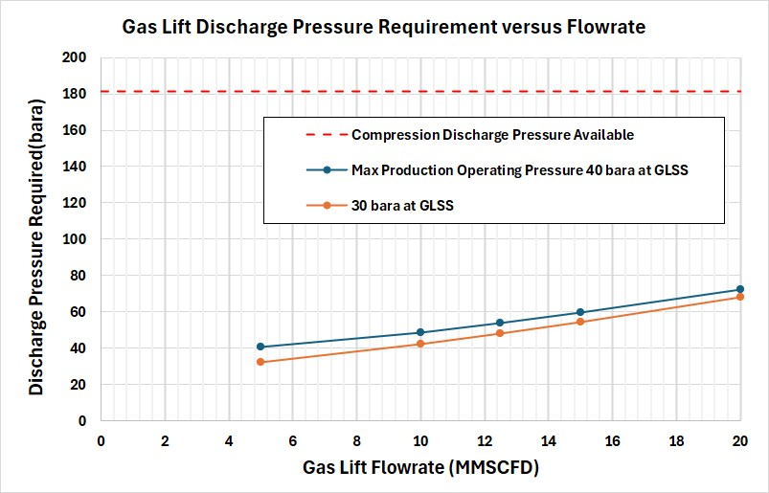
Figure 6-2 –Gas Lift – Required Discharge Pressure versus Flowrate

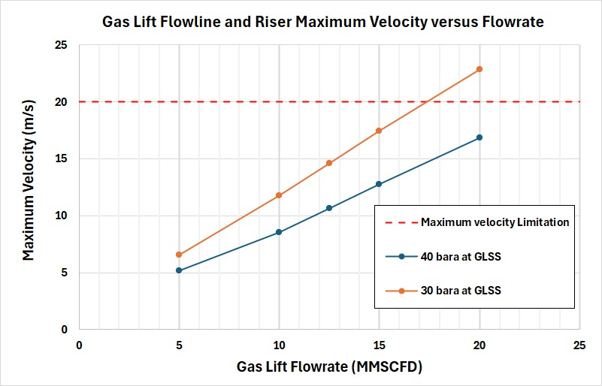
Figure 6-3 –Gas Lift – Velocity versus Flowrate
RESULTS – WATER INJECTION SYSTEM
Figure 7-1 shows the water injection system schematic. There is only one water injection well and the system has one dedicated riser, flowline and manifold for water injection.
Figure 7-1 – EBAN Water Injection System – Schematic
Water Injection Profiles
The following Figure 7-2 illustrates the water injection flowrates forecast from the water injection profile and the required tubing head pressures (Ref. section 8.2). There is only one water injection well with a peak flowrate of 10,477 stbd. The water injection system requires to meet the tubing head pressures with a maximum value of 131 bar.
Figure 7-1 above shows the water injection system schematic. There is only one water injection well and the system has one dedicated riser, flowline and manifold for water injection. The target injection pressure at the wellhead ranges from 120.5 to 131 bara.
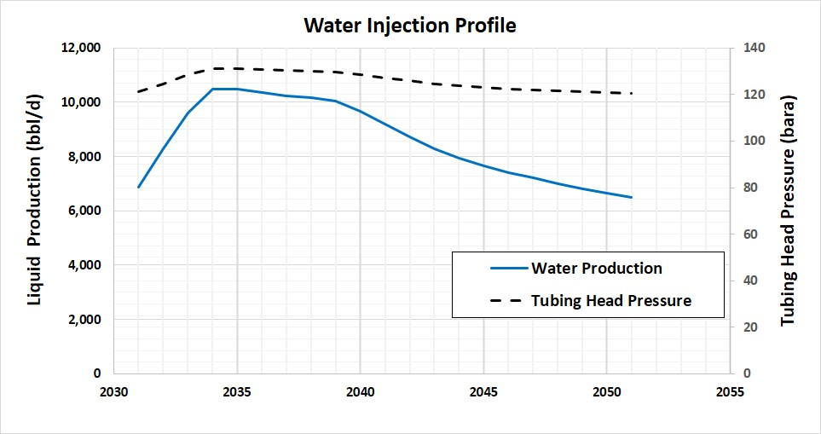
Figure 7-2 – Water Injection flowrates
Water Injection Steady State Results
For the whole water injection system, steady state analysis has been carried out to verify the topside pressure requirement along the asset life and any potential issue due to high velocity or EVR during steady conditions. The system has been modelled form topside to well-head of each injection well.
The main results can be summarized as follows:
- The flexible pipeline diameter of 6-inch ID is sufficient size to deliver the water requirements. The maximum discharge pressure requirement is about 103 bara as reported in
- Water velocity and EVR are within the minimum process design requirements.
- Maximum velocity of 1 m/s with an associated average EVR of 0.3 are observed in the dedicated WI riser and flowline up to the water injection well WI-1X
- The discharge temperature tends towards ambient conditions but stays above at 10 and 7 deg C for the maximum and minimum flowrate cases respectively.

Case | Flowrate  [bbl/d] | Required Discharge Pressure  [bara] | Wellhead Pressure  [bara-] | Velocity Flowline Inlet  [m/s] | Velocity Flowline Outlet  [m/s] | Average Flowline  EVR  [-] | Temperature Inlet  [C] | Temperature  Outlet  [C]
Maximum  Flowrate | 10400 | 103 | 131 | 1.0 | 1.0 | 0.3 | 25 | 10
Minimum  Flowrate | 6500 | 96 | 131 | 0.7 | 0.7 | 0.2 | 25 | 7
Table 7-1 – Water Injection Outcomes – 6inch Maximum and Minimum Flow
A sensitivity was performed for a 4in flexible flowline. The results are listed in Table 7-2. There is an increased pressure requirement of 182 bara for the maximum velocity case and the velocity and EVR increase to 2.4m/s and 0.6 respectively. These are also within acceptable limits but the 6 inch size is chosen. Due to the higher velocity the water arrives at the wellhead at slightly higher temperatures
Case | Flowrate  [bbl/d] | Required Discharge Pressure  [bara] | Wellhead Pressure  [bara-] | Velocity Flowline Inlet  [m/s] | Velocity Flowline Outlet  [m/s] | Average Flowline  EVR  [-] | Temperature Inlet  [C] | Temperature  Outlet  [C]
Maximum  Flowrate | 10400 | 182 | 131 | 2.4 | 2.4 | 0.6 | 25 | 13
Minimum  Flowrate | 6500 | 126 | 131 | 1.5 | 1.5 | 0.4 | 25 | 9
Table 7-2 – Water Injection Outcomes – 4inch Maximum and Minimum Flows

ATTACHMENTS

Subsea Upstream and Downstream Chokes



Initial Line Sizing - Configuration Screening Presentation



